**AIM :** To make automatic night lighting system such that the system is only activated with switch connection .

Condition : (A) Below 300 lux led glows with full brightness

(B) Above 300lux led glows with 50% brightness

**APPRATUS :** 1 LED, 1 switch, breadboard, wires, Arduino,2 resistors, LDR sensor.

**CIRCUIT DIAGRAM:**

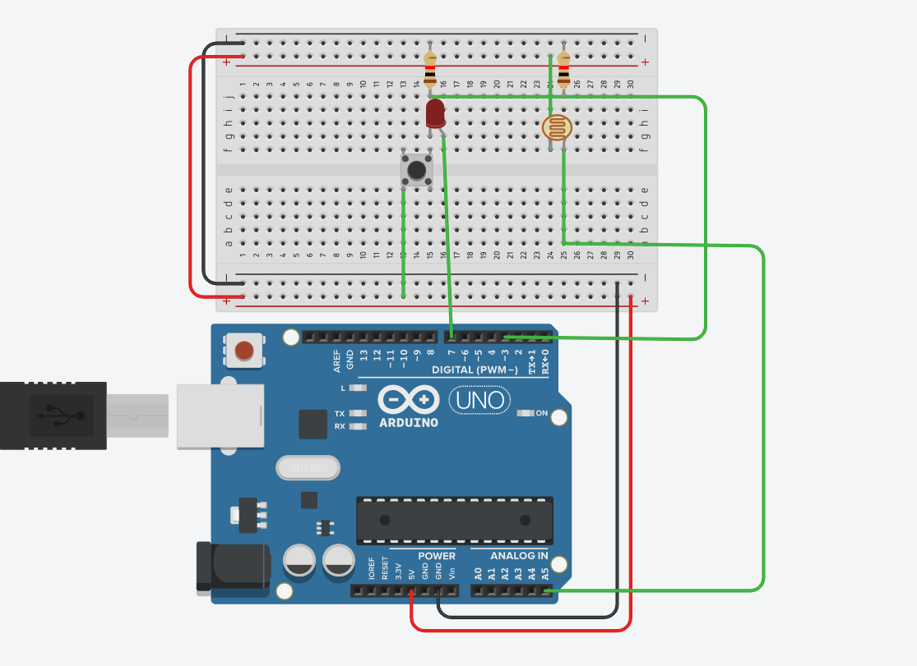

**THEORY** :

Working of LRD Sensor as it senses the luminous intensity.

**LEARNING & OBSERVATION :**

1. Learned how to connect the connection inside the breadboard.
2. Connection of LED in the breadboard and which is n side & p side of LED.
3. Learned how to upload code on Arduino and work on it.
4. Learned how to connect LDR Sensor with Arduino and its use.
5. Learned how to use the switch to control the LED.

**PROBLEM & TROUBLESHOOTING:**

1. Connection of switch,led and LDR to breadboard was tough.
2. Mistake in code uploading.

**LEARNING OUTCOMES**:

1. Connection to breadboard.
2. Use of LDR Sensor to the Arduino.
3. Use switch with led.